William Parrott

Transcription of Obituary in the Primitive Methodist Magazine by Thomas Markwell

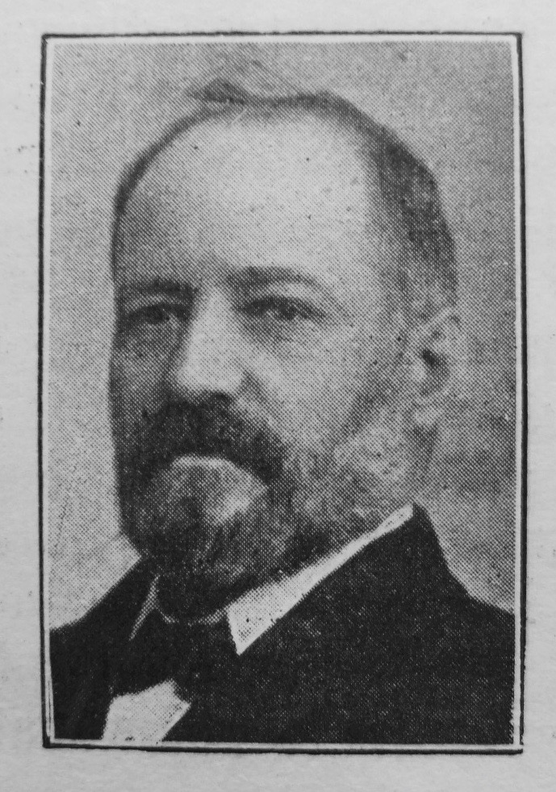
Mr. William Parrott, M.P., was born at Row Green, Wellington, Somersetshire, on December 18th, 1843. At an early period in his childhood, the family removed into Yorkshire, where he resided during the succeeding years of his earthly sojourn. At a very early period he began to work in a brickyard, and was hardly ten years of age when he commenced to labour in a coal mine, in which kind of work he was employed many years. While working in the pit he twice narrowly escaped death.

In the year 1871 he was in the workings when an explosion took place, and he only saved his life by running through the fire.

On another occasion he was seriously injured by a fall of coal, and for some time his life was in danger.

He was converted in his twenty-first year at Methley, then in the Leeds IV. Circuit. Then he became a member with our people there: he likewise became a trustee of our place of worship in the village. He entered heartily into Sunday School work, and about two years after his conversion he became a local preacher. He had much joy in such work for fourteen or sixteen years.

He removed to Barnsley in 1881, and forthwith united with our church in Westgate, where for a few years he held the office of class leader, and was a liberal supporter of the funds. He was held in high estimation by the ministers of his acquaintance, some of whom testify as follows:

The Rev. L.E. Ellis says: “I have had abundant opportunities of observing Mr. Parrott in the discharge of his duties, both in public and private life, and have never known him to fail or falter. His was a truly Christly spirit, and that spirit characterised his conduct in all the relationships of life.”

The Rev. C. Dudley says: “Mr. Parrot was a man of sterling worth, and bristling with sound common sense. He regarded the principles of Liberalism as part of his religion, and wherever he was, and into whatever company he was thrown, he always acknowledged that he owed his position to the religion of the Lord Jesus.”

Rev. W. Hufﬁngton says: “He was conscientious, conciliatory and brave, not only resisting the policy of the masters when opposed to the true interests of the men, but also those demands of the men which he regarded as unjust.”

Rev. J. Teece says: “He was deeply interested in the welfare of the people, especially the miners. How thoughtful and reasonable he was in his advice and in his efforts to serve them! As a Christian I knew him to be devout, humble, considerate, showing in his life and in his service for men the Spirit of Jesus Christ. As a friend he was faithful and kind. The honours that came to him in no sense spoiled him, he remained the same honest, honourable, manly, William Parrott.”

Although a man of great energy and a strenuous worker for the Yorkshire Miners’ Association, of which he was the General Secretary, and representing Normanton Parliamentary Division in the House of Commons, he was not a robust man, and without doubt the heavy pressure of his duties was too serious for his physical constitution.

He was remarkably calm under the attack of the illness that proved fatal, and for the end he was well prepared. He had served his generation by the will of God, and fell asleep on November 9th, 1905.

The general respect he had won in the town and district by his character and life, was evinced by the immense concourse of people who attended his funeral; also the large, sympathetic congregation that assembled in the Westgate Chapel at the memorial service conducted by the writer of these lines.
__________________________________________________________________________________
References
Primitive Methodist Magazine 1906/904

